**Carotid Artery Stiffness Mechanisms, Heart Failure Events and Atrial Fibrillation in MESA: The Multi-Ethnic Study of Atherosclerosis**

Ryan Pewowaruk1, Claudia Korcarz2, David A. Bluemke3, Mohamed H. Hamdan2, Susan R. Heckbert4, Joao A. C. Lima5, Yacob Tedla6, and Adam D. Gepner2,7

1. Ryan Pewowaruk Research Consulting, Madison, WI
2. University of Wisconsin – Madison, Department of Medicine, Madison, WI
3. University of Wisconsin – Madison, Department of Radiology, Madison, WI
4. University of Washington School of Public Health, Seattle, WA
5. Johns Hopkins School of Medicine, Baltimore, MD
6. Vanderbilt University School of Medicine, Nashville, TN
7. William S. Middleton Memorial Veterans Hospital, Madison, WI

**Arterial Stiffness Models**

Total, structural, and load-dependent carotid artery pulse wave velocity (PWV) will be calculated as previously described in MESA (1,2):

Participant specific exponential curves are used to account for the effect of blood pressure on arterial stiffness and changing arterial diameter:

$$\begin{aligned}P=P_{d}e^{γ\left(\frac{D^{2}}{D_{d}^{2}}-1\right) }\#\left(S1\right)\end{aligned}$$

where the non-linear stiffness parameter ($γ$) was described:

$$\begin{aligned}γ=\frac{\ln\left(\frac{P_{s}}{P_{d}}\right)}{\frac{D_{s}^{2}}{D_{d}^{2}}-1}\#\left(S2\right)\end{aligned}$$

The arterial diameter at an arbitrary pressure of A/B mmHg is determined with the following equations:

$$\begin{aligned}D_{A}^{2}=D_{d}^{2}\left(\frac{\ln\left(\frac{A}{P_{d}}\right)}{γ}+1\right)\#\left(S3\right)\end{aligned}$$

$$\begin{aligned}D_{B}^{2}=D_{d}^{2}\left(\frac{\ln\left(\frac{B}{P_{d}}\right)}{γ}+1\right)\#\left(S4\right)\end{aligned}$$

PWV is then calculated at an arbitrary pressure A/B:

$$\begin{aligned}{PWV}_{A/B}=\sqrt{\frac{1}{ρ} \frac{\left(A-B\right)D_{B}^{2}}{\left(D_{A}^{2}-D_{B}^{2}\right)}}\#\left(S5\right)\end{aligned}$$

where $ρ$ is the density of blood (1050 kg/m3). This equation can also be expressed as

$$\begin{aligned}PWV_{120/80}=\sqrt{\frac{1}{ρ} \frac{\left(A-B\right)}{\ln\left(\frac{A}{B}\right)}\left(γ+\ln\left(\frac{B}{P_{d}}\right)\right)}.\#\left(S6\right)\end{aligned}$$

Structural stiffness was determined with the prior equations at a pre-determined blood pressure of 120/80 mmHg. Total arterial stiffness was determined with the prior equations by using the measured participant blood pressure. Load-dependent stiffness was calculated from the difference between total arterial stiffness and structural arterial stiffness. If the blood participant’s blood pressure was over 120/80, load-dependent stiffness was positive. Prior research has found that the choice of the reference BP range does not impact study findings 16,17, therefore we selected 120/80 mmHg as it considered the standard normal BP

**Directed Acyclic Graph (DAG)**

**Figure S1:** Model co-variates were selected based on the above directed acyclic graph (DAG, figure created with DAGitty (3)). For simplicity of visualizing the model, demographics includes age, sex, race/ethnicity, education level, and study site. The double headed arrows between hypertension, diabetes, and dyslipidemia indicate that these diseases highly co-morbid but do not have a strong causal influence on each other. For instance, based on Mendelian randomization studies there is not a strong causal influence between hypertension and diabetes (4). Instead, the co-morbidity is likely due to underlying biological processes and unmeasured risk factors that contribute to the development of these chronic diseases(5). We do not include an effect of hypertension or blood pressure on structural arterial stiffness because several clinical studies have shown that hypertension does not increase structural stiffness (6–8). We separate out RAAS inhibitors from other blood pressure medications as there is some evidence that ACE inhibitors and ARBs can decrease arterial stiffness independent of blood pressure (9,10). Based on these assumptions the minimum necessary co-variates to estimate the total effect of carotid artery stiffness on heart failure and atrial fibrillation events were:

Structural stiffness: Age, sex, race/ethnicity, study site, education level, diabetes, and RAAS inhibitor use

Total and Load-dependent stiffness: Same co-variates as structural stiffness plus mean arterial pressure (MAP)

The additional co-variates (smoking, hypertension, any blood pressure medication use, total cholesterol, HDL cholesterol, and lipid medication) were included to improve the efficiency of the statistical analysis (11).

**Supplemental Results**

Figure S2 and S3 shows unadjusted freedom from HF event (Figure S2) and AF diagnosis (Figure S3) curves by quartiles of structural and load-dependent stiffness.

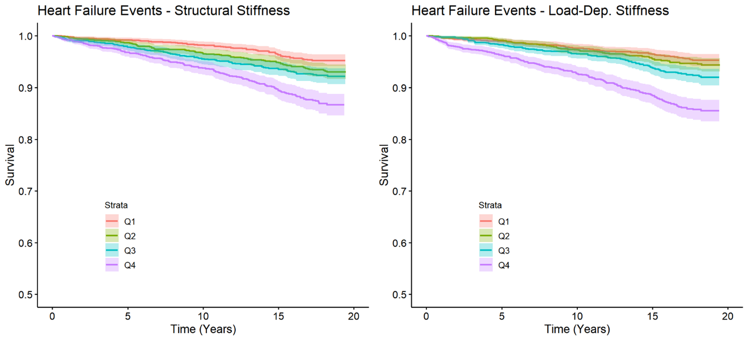

**Figure S2:** Unadjusted Kaplan-Meier curves showing heart failure event free survival curves for participants in different quartiles of A. structural stiffness, and B. load-dependent stiffness. Note that the Kaplan-Meier curves are not adjusted any co-variates.

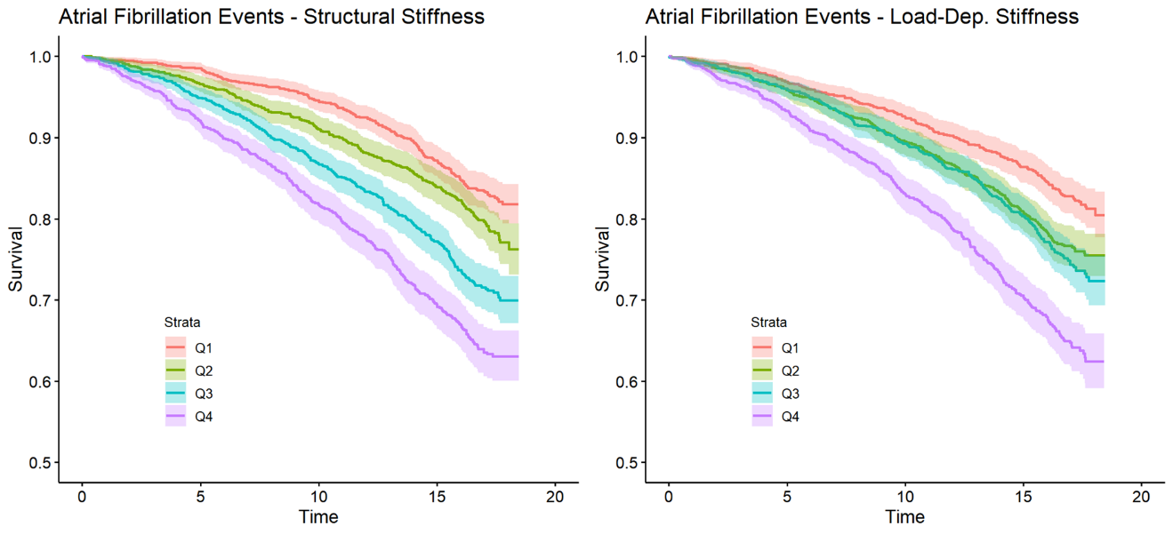

**Figure S3:** Unadjusted Kaplan-Meier curves showing atrial fibrillation diagnosis free survival curves for participants in different quartiles of A. structural stiffness, and B. load-dependent stiffness. Note that the Kaplan-Meier curves are not adjusted any co-variates.

60 participants with HF events were excluded from analysis of HFrEF and HFpEF events because it could not be determined if the HF event was HFrEF or HFpEF. Out of 6218 participants there were 184 HFrEF events and 163 HFpEF events. The HRs from Cox regression models for HFrEF and HFpEF events are reported in Table S1, although given the small number of HFrEF and HFpEF events we caution readers to not overinterpret these findings.

**Table S1: Associations of Stiffness Parameters with Heart Failure Events and Atrial Fibrillation Diagnosis**

|  |  |  |  |  |
| --- | --- | --- | --- | --- |
|  | Model 1 (Demographics, Risk Factors, MAP) | | Model 2 (Model 1 + Pulse Pressure) | |
|  | HR per 1 m/s [95% CI] | p-value | HR per 1 m/s [95% CI] | p-value |
| All Congestive Heart Failure Events (407 events in 6278 participants) | | | | |
| Total PWV | 1.06 [1.00 - 1.13] | 0.069 | 1.05 [0.99 - 1.12] | 0.11 |
| Structural PWV | 1.04 [0.97 - 1.12] | 0.23 | 1.04 [0.96 - 1.11] | 0.33 |
| Load-Dependent PWV | 1.37 [1.08 - 1.74] | 0.010 | 1.37 [1.08 - 1.73] | 0.009 |
| Atrial Fibrillation Diagnosis (1157 in 5292 participants) | | | | |
| Total PWV | 1.06 [1.02- 1.11] | 0.003 | 1.06 [1.02- 1.11] | 0.004 |
| Structural PWV | 1.06 [1.01 - 1.11] | 0.013 | 1.06 [1.01 - 1.10] | 0.017 |
| Load-Dependent PWV | 1.19 [1.03 - 1.37] | 0.021 | 1.19 [1.03 - 1.37] | 0.020 |
| Heart Failure with Reduced Ejection Fraction Events (184 events in 6218 participants) | | | | |
| Total PWV | 1.12 [1.02 - 1.23] | 0.021 | 1.11 [1.01- 1.22] | 0.029 |
| Structural PWV | 1.10 [0.99 - 1.22] | 0.082 | 1.09 [0.98 - 1.21] | 0.11 |
| Load-Dependent PWV | 1.60 [1.12 - 2.29] | 0.010 | 1.60 [1.12 - 2.28] | 0.010 |
| Heart Failure with Reduced Ejection Fraction Events (163 events in 6218 participants) | | | | |
| Total PWV | 1.00 [0.90- 1.12] | 0.96 | 1.00 [0.90- 1.11] | 0.96 |
| Structural PWV | 0.99 [0.89 - 1.12] | 0.92 | 0.99 [0.88 - 1.12] | 0.82 |
| Load-Dependent PWV | 1.11 [0.76 - 1.62] | 0.60 | 1.11 [0.76 - 1.62] | 0.58 |

Hazard ratios (HR) with 95% confidence intervals calculated from Cox hazard models adjusted for:

Model 1: Age, sex, race, study site, education, smoking, diabetes, hypertension, blood pressure medication, RAAS inhibitor, total cholesterol, HDL cholesterol, lipid medication, and mean arterial pressure (MAP)

Model 2: Model 1 + pulse pressure

**Table S2: Associations of All Model Co-variates with Heart Failure Events and Atrial Fibrillation Diagnosis: Note that estimates should not be interpreted causally**

|  |  |  |
| --- | --- | --- |
|  | Heart Failure Events  (HR [95% CI]) | Atrial Fibrillation Diagnosis  (HR [95% CI]) |
| Total PWV (per m/s) | 1.05 [0.99, 1.12] | 1.06 [1.02, 1.11] |
| Age (per 10-years) | 1.95 [1.70, 2.24] | 2.26 [2.078, 2.45] |
| Male (vs female) | 1.82 [1.41, 2.34] | 1.58 [1.36, 1.84] |
| Chinese Ethnicity (vs white) | 0.66 [0.41, 1.06] | 0.78 [0.62, 0.99] |
| Black (vs white) | 0.79 [0.60, 1.02] | 0.64 [0.55, 0.76] |
| Hispanic / Latino (vs white) | 0.67 [0.48, 0.94] | 0.66 [0.54, 0.82] |
| Grades 1-8 vs No School | 0.74 [0.40, 1.35] | 0.76 [0.55, 1.06] |
| Grades 9-11 vs No School | 1.17 [0.65, 2.10] | 1.27 [0.93, 1.73] |
| High School / GED vs No School | 0.77 [0.45, 1.31] | 0.82 [0.61, 1.10] |
| Some College vs No School | 0.88 [0.58, 1.31] | 1.08 [0.86, 1.36] |
| Technical School Certificate vs No School | 1.10 [0.79, 1.55] | 0.93 [0.76, 1.13] |
| Associate Degree vs No School | 0.97 [0.69, 1.37] | 1.04 [0.84, 1.29] |
| Bachelors Degree vs No School | 1.09 [0.77, 1.53] | 1.05 [0.84, 1.30] |
| Graduate School vs No School | 0.99 [0.74, 1.33] | 0.92 [0.77, 1.103] |
| Site Colombia (vs Wake Forrest) | 0.76 [0.54, 1.07] | 1.09 [0.86, 1.37] |
| Site Johns Hopkins (vs Wake Forrest) | 0.48 [0.34, 0.69] | 1.29 [1.05, 1.58] |
| Site Minnesota (vs Wake Forrest) | 0.91 [0.65, 1.27] | 0.83 [0.65, 1.04] |
| Site Northwestern (vs Wake Forrest) | 0.65 [0.45, 0.90] | 1.13 [0.92, 1.40] |
| Site UCLA (vs Wake Forrest) | 0.61 [0.42, 0.90] | 1.38 [1.10, 1.74] |
| Body Mass Index (per 1 kg/m2) | 1.05 [1.03, 1.07] | 1.03 [1.02, 1.05] |
| Former smoker (vs never) | 1.34 [1.08, 1.67] | 1.11 [0.98, 1.27] |
| Current smoker (vs never) | 1.95 [1.41, 2.70] | 1.66 [1.36, 2.03] |
| Impaired Fasting Glucose (vs Non-diabetic) | 1.02 [0.76, 1.37] | 0.93 [0.79, 1.11] |
| Untreated Diabetes (vs Non-diabetic) | 1.63 [0.99, 2.69] | 1.03 [0.72, 1.47] |
| Treated Diabetes (vs Non-diabetic) | 2.08 [1.57, 2.75] | 1.09 [0.89, 1.33] |
| Hypertension | 1.33 [0.96, 1.85] | 1.02 [0.84, 1.24] |
| Anit-hypertensive Medication Use | 1.19 [0.88, 1.62] | 1.22 [1.02, 1.46] |
| RAAS-inhibitor Use | 1.23 [0.94, 1.61] | 1.01 [0.85, 1.20] |
| Total Cholesterol (per 10 mg/dL) | 1.00 [0.97, 1.03] | 0.99 [0.97, 1.00] |
| HDL Cholesterol (per 10 mg/dL) | 1.02 [0.94, 1.10] | 1.04 [0.99, 1.08] |
| Lipid Medication Use | 0.85 [0.66, 1.09] | 0.94 [0.81, 1.088] |
| Mean Arterial Pressure (per 10 mmHg) | 0.98 [0.88, 1.10] | 1.023 [0.95, 1.10] |
| Pulse Pressure (per 10 mmHg) | 1.11 [1.02, 1.20] | 1.02 [0.97, 1.08] |

Hazard ratios (HRs) for the association of all model co-variates with all heart failure events and atrial fibrillation diagnosis. HRs calculated from Cox hazard models adjusted for all of the other variables listed in the table. Note that these estimates should not be interpreted causally due to the “Table 2 Fallacy” 18.

**References**

1. Bild DE, Bluemke DA, Burke GL, Detrano R, Diez Roux AV, Folsom AR, Greenland P, Jacobs DR, Kronmal R, Liu K, Nelson JC, O’Leary D, Saad MF, Shea S, Szklo M, et al. Multi-Ethnic Study of Atherosclerosis: Objectives and design. *American Journal of Epidemiology*. 2002;156(9):871–881.

2. Friedewald WT, Levy RI, Fredrickson DS. Estimation of the concentration of low-density lipoprotein cholesterol in plasma, without use of the preparative ultracentrifuge. *Clinical chemistry*. 1972;18(6):499–502.

3. Gepner AD, Korcarz CE, Colangelo LA, Hom EK, Tattersall MC, Astor BC, Kaufman JD, Liu K, Stein JH. Longitudinal effects of a decade of aging on carotid artery stiffness : The multiethnic study of atherosclerosis. *Stroke*. 2014;45(1):48–53.

4. Blaha MJ, Budoff MJ, Rivera JJ, Katz R, O’Leary DH, Polak JF, Takasu J, Blumenthal RS, Nasir K. Relationship of carotid distensibility and thoracic aorta calcification: Multi-ethnic study of atherosclerosis. *Hypertension*. 2009;54(6).

5. Heckbert SR, Wiggins KL, Blackshear C, Yang Y, Ding J, Liu J, McKnight B, Alonso A, Austin TR, Benjamin EJ, Curtis LH, Sotoodehnia N, Correa A. Pericardial fat volume and incident atrial fibrillation in the Multi-Ethnic Study of Atherosclerosis and Jackson Heart Study. *Obesity*. 2017;25(6).

6. Textor J, van der Zander B, Gilthorpe MS, Liśkiewicz M, Ellison GT. Robust causal inference using directed acyclic graphs: The R package “dagitty.” *International Journal of Epidemiology*. 2016;45(6).

7. Sun D, Zhou T, Heianza Y, Li X, Fan M, Fonseca VA, Qi L. Type 2 Diabetes and Hypertension: A Study on Bidirectional Causality. *Circulation Research*. 2019;124(6).

8. Colussi GL, Da Porto A, Cavarape A. Hypertension and type 2 diabetes: lights and shadows about causality. *Journal of Human Hypertension*. 2020;34(2).

9. Pewowaruk RJ, Korcarz CE, Tedla YG, Mitchell CC, Gepner AD. Carotid Artery Stiffness Mechanisms in Hypertension and their Association with Echolucency and Texture Features: The Multi-Ethnic Study of Atherosclerosis (MESA). *Ultrasound in Medicine & Biology*. 2022;48(11):2249–2257.

10. Laurent S, Caviezel B, Beck L, Girerd X, Billaud E, Boutouyrie P, Hoeks A, Safar M. Carotid artery distensibility and distending pressure in hypertensive humans. *Hypertension*. 1994;23(6):878–883.

11. Bussy C, Boutouyrie P, Lacolley P, Challande P, Laurent S. Intrinsic stiffness of the carotid arterial wall material in essential hypertensives. *Hypertension*. 2000;35(5):1049–1054.

12. Ong KT, Delerme S, Pannier B, Safar ME, Benetos A, Laurent S, Boutouyrie P. Aortic stiffness is reduced beyond blood pressure lowering by short-term and long-term antihypertensive treatment: A meta-analysis of individual data in 294 patients. *Journal of Hypertension*. 2011;29(6):1034–1042.

13. Laurent S, Boutouyrie P. Dose-dependent arterial destiffening and inward remodeling after olmesartan in hypertensives with metabolic syndrome. *Hypertension*. 2014;64(4):709–716.

14. Cinelli C, Forney A, Pearl J. A Crash Course in Good and Bad Controls. *Sociological Methods and Research*. 2022.

15. Therneau Terry. A Package for Survival Analysis in R. *R package version 3.5-0*. 2023.

16. Pewowaruk RJ, Tedla Y, Korcarz CE, Tattersall MC, Stein JH, Chesler NC, Gepner AD. Carotid Artery Stiffening With Aging: Structural Versus Load-Dependent Mechanisms in MESA (the Multi-Ethnic Study of Atherosclerosis). *Hypertension*. 2021;(January):1–9.

17. Pewowaruk RJ, Korcarz C, Tedla Y, Burke G, Greenland P, Wu C, Gepner AD. Carotid Artery Stiffness Mechanisms Associated With Cardiovascular Disease Events and Incident Hypertension: the MESA. *Hypertension*. 2022;79(3):659–666.

18. Westreich D, Greenland S. The table 2 fallacy: Presenting and interpreting confounder and modifier coefficients. *American Journal of Epidemiology*. 2013;177(4).